Javeria Riaz (2016-CS-251)

Menahal Hassan (2016-CS-260)

Story Board

Super mario bros

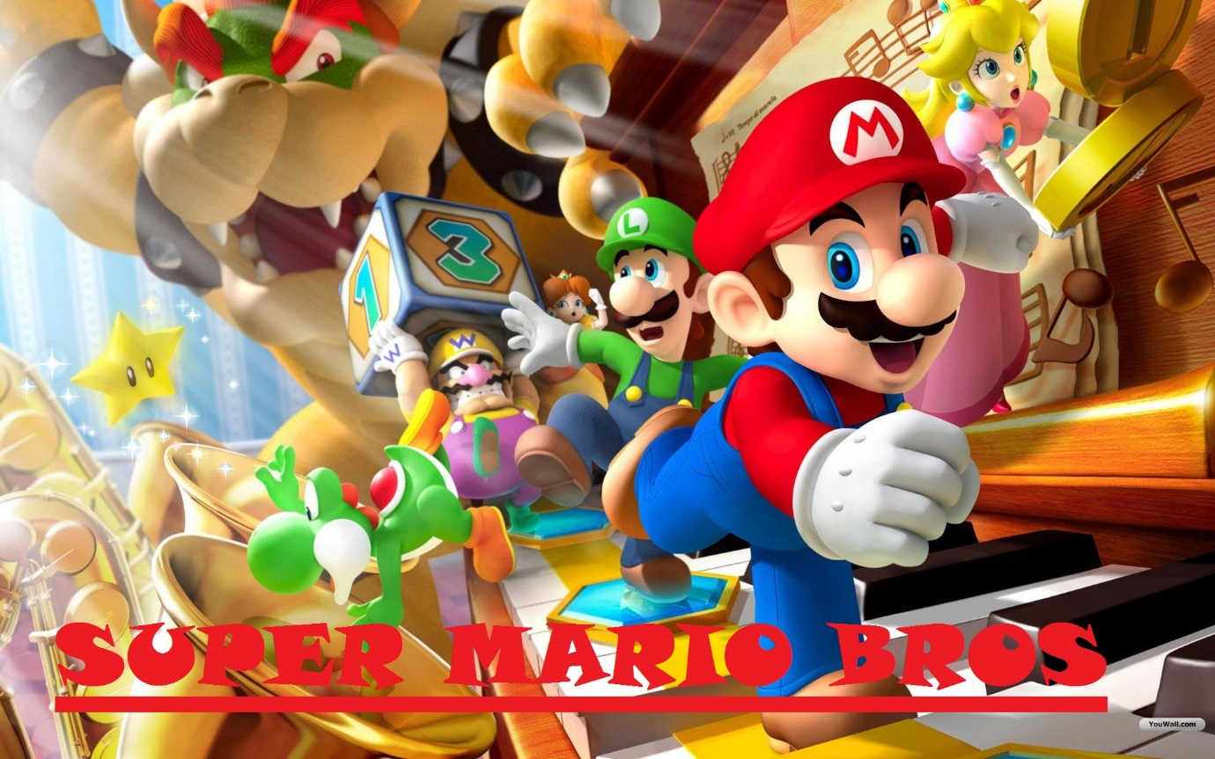  
The game takes place in Mushroom Kingdom, a place similar to Earth where Mario, a plumber is on a quest to save the princess Peach from Bowser, a deadly villain.

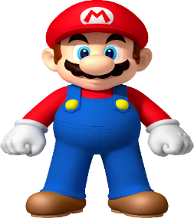**CHARACTERS :**

**Mario :**

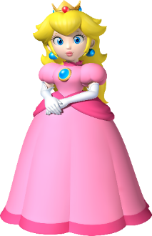Mario is the main character which is dressed with brown red clothes. He faces many hurdles in rescuing Princess Peach.

**Princess Peach :**

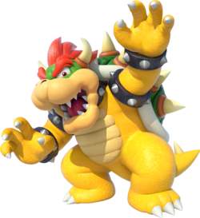Princess Peach is the princess of Mushroom Kingdom. She wears white and pinkish red dress and has long hair and tiny orange crown. She was made to be damsel-in-distress.

**Bowser :**

Bowser is primary antagonist. He is leader of Koopas. He has never stopped to attempt to kidnap Princess Peach of Mushroom Kingdom.

**Attacking Enemies :**



Basic attacking enemy is Goomba. They appear in every level to stop Mario.

**LEVELS :**

There will be fours levels in this game. Following is the description of levels.

|  |  |  |
| --- | --- | --- |
| Level | CONSTRUCTION | DESCRIPTION |
| 1 |  | **Overworld :**  Overworld is most basic world, it is being similar to our world in that there is sky, clouds, normal buildings. |
| 2 |  | **Underground :**  The underground is the basic level opposite of overworld. It is dark, gloomy. There are many man eating plants in this level. |
| 3 |  | **Athletic :**  Athletic level takes place above overworld. Here many Mushrooms falling from the sky trying to attack Mario. |
| 4 |  | **CASTLE :**  It is dark and intimidating with grey stone walls. The place is full of dangerous things. Here Mario will fight with the main enemy Bowser. |

**GAME PLANNER :**

|  |  |
| --- | --- |
| GAME NAME | Super Mario Bros |
| PRIMARY GENRE | Adventure Game |
| GAME PLATFORM USED | BYOB |
| MAIN GOAL | Primary goal is to reach the end of each level to fight Bowser as to save Princess Peach in the end. |
| TARGET USER | For Kids |
| SPRITES USED | Maximum 100 Sprites.  Mario, bowser, princess, goombas, coins, backgrounds etc. |
| BACKGROUNDS USED | There are 4 backgrounds used for 4 levels |
| INSTRUCTIONS | 1)Left and right arrow keys must to used to move left and right respectively  2)Player should should shoot the enemies by pressing space bar in order to protect himself.  3)Running into enemies horizontally or touching the enemies shooter will cause the player to take damage.  4)The player has five lives in every level which he will lose if he touches the enemy or enemy shooter.  5)On losing five lives, game will be over. |
| WIN CONDITION | When Mario kills Bowser player wins the game |
| SCORE | Mario has to take coins present on each level |
| MUSIC USED | Mario Game’s traditional music and sound |